**I HAD A LATIN MOMENT!**

What I saw or heard that came from or relates to Where I saw or heard it:

Latin, Greek, ancient Rome, or ancient Greece: TSC

Asus Maximus III, a state of the art motherboard

If it is a word or phrase in English or Latin, what does it mean?

Latin- Important/Big

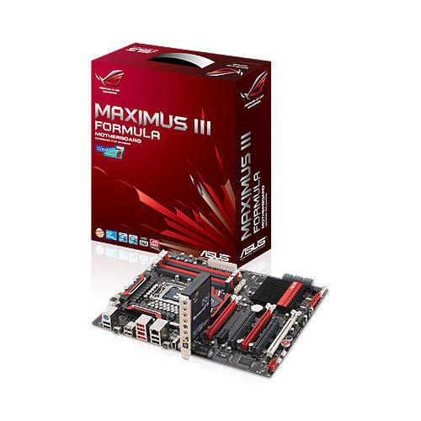

How does this relate to Latin, Greek ancient Rome, or ancient Greece? That is, why is this a Latin Moment?

They’re still using latin words, often used to emphasize things, such as aqueducts, and stadiums for new technologies. In a weird way, computers are the new aqueducts.

(Please bring in any newspaper articles, pictures, advertisements, or other sources for your Latin Moment. Staple them to this sheet.)

**I HAD A LATIN MOMENT!**

What I saw or heard that came from or relates to Where I saw or heard it:

Latin, Greek, ancient Rome, or ancient Greece: In my audio editing

Latin

Audacity is audio editing software

If it is a word or phrase in English or Latin, what does it mean?

Audacity normally means to take bold risks, but this company used the latin meaning of sound for audio editing software!

How does this relate to Latin, Greek ancient Rome, or ancient Greece? That is, why is this a Latin Moment?

They still pay attention to latin roots rather than the meaning of the word to generate new meanings for the word.

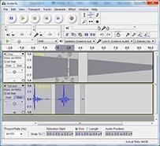

**I HAD A LATIN MOMENT!**

What I saw or heard that came from or relates to Where I saw or heard it: Amazon

Latin, Greek, ancient Rome, or ancient Greece:

Latin

Harry Potter is written in latin

If it is a word or phrase in English or Latin, what does it mean?

No, it is a modern book written completely in latin.

How does this relate to Latin, Greek ancient Rome, or ancient Greece? That is, why is this a Latin Moment?

It shows that latin is still notable, and worth learning

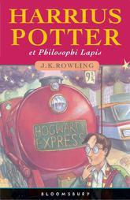

**I HAD A LATIN MOMENT!**

What I saw or heard that came from or relates to Where I saw or heard it:

Latin, Greek, ancient Rome, or ancient Greece: ICS

Latin: a Book that said Missale Romanum, upon going back to visit my old religion teacher, among others at Immaculate Conceptions school, we were talking about some theological concepts and upon going to show her a phrase, I realized on the front of the book it said “Missale Romanum”: Roman Bible was the translation she rendered me.

If it is a word or phrase in English or Latin, what does it mean?

Latin: Roman Bible

How does this relate to Latin, Greek ancient Rome, or ancient Greece? That is, why is this a Latin Moment?

Latin: In the later years of the roman empire and only after years of persecution Roman Catholic became the rule of the land in ancienct Rome.

(Please bring in any newspaper articles, pictures, advertisements, or other sources for your Latin Moment. Staple them to this sheet.)

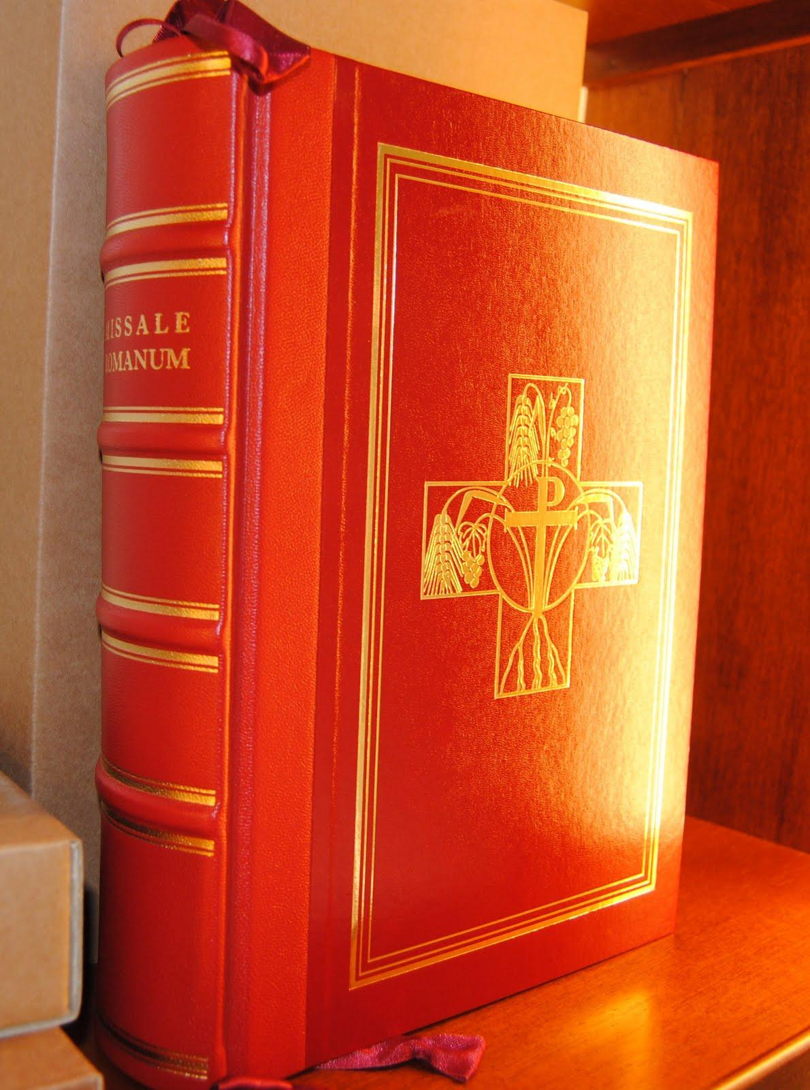

Not actual book.